Music Investigation 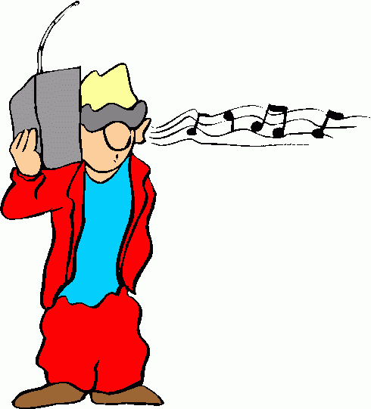
Integrated Science Year 12
Part A:
Designing and conducting an experiment using the Scientific Method. (5 marks)
Teenagers are often told by their parents not to play their music so loud because it will damage their hearing. Using a music player and headphones design and conduct an experiment to find out if you listening habits are putting you at risk of noise induced hearing loss.
Upon completion of your experiment write up your findings using the standard headings of the Scientific Method.
Things to consider; 
What is your hypothesis?
What equipment is required to do this experiment?
How should the experiment be performed?
What are the experiments variables?
How are your results to be analysed and presented?
Do you always listen to music at the same volume?
Is it worth comparing your typical relaxing music volume with the party time volume?
How do your results compare with others in the class? Is it worth taking a larger sample to test your hypothesis?
DUE DATE: ____________________

Part B Hearing (5marks)
Comparing research with the results of an investigation
Use the internet to research the following questions.
1. What is the generally accepted frequency range of human hearing?
2. Produce a table that correlates age with hearing loss.
3. Using more than one hearing test to compare your hearing with your “hearing age”. Show your findings and provide details (referencing) of the tests used.
4. Provide a diagram that displays common activities on one axis and their decibel levels on another axis. (At least 12 common activities e.g. lawn mowing)
5. Display a table which shows decibel level and the time taken to produce hearing damage.
6. Compare the data on the table above (6.) with your experiment results in part A. Explain the long term implications of your music listening habits.
7. You are the Head of a small company and are required to produce a sign suggesting 6 steps to minimising hearing loss at work. What are the six steps you would include on your sign?
8. Make a list of the top 10 sounds/noises you have been exposed to that are likely to have already damaged your hearing.



